# Project Design Phase-I Solution Architecture

|  |  |
| --- | --- |
| Date | 5th October 2022 |
| Team ID | PNT2022TMID42920 |
| Project Name | Project – Natural Disaster Intensity Analysis and Classification Using Artificial Intelligence |
| Maximum Marks | 4 Marks |

**Solution Architecture:**

Solution architecture is a complex process – with many sub-processes – that bridges the gap between business problems and technology solutions. Its goals are to:

* Find the best tech solution to solve existing business problems.
* Describe the structure, characteristics, behavior, and other aspects of the software to project stakeholders.
* Define features, development phases, and solution requirements.
* Provide specifications according to which the solution is defined, managed, and delivered.

# Example - Solution Architecture Diagram:

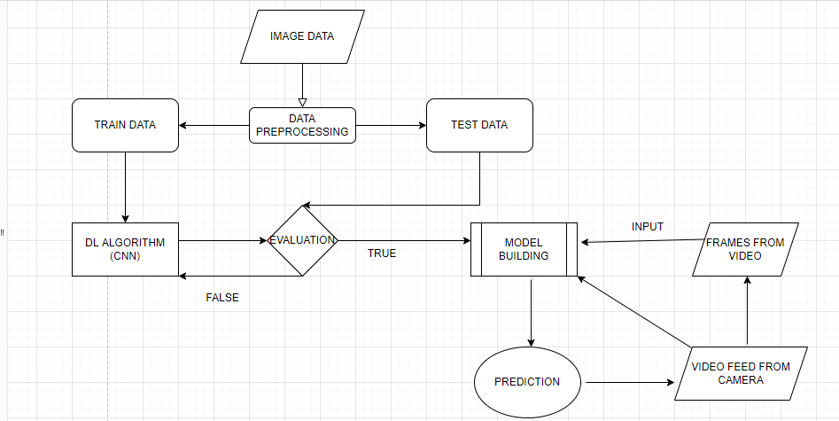

Fig 1. Architecture and Flow Diagram to classify the natural disaster using Deep Learning Algorithms

# Submitted by:

S.SABARISHAN (712819104025) S.B.KAVINRAJ (712819104717)

G.ARJUNKUMAR (712819104711) A.MANOJ (712819104018)